Motors

LOTI.05.010 Robotics

Spring semester 2015/16

Practice session 4
In this lab you will learn how to control regular DC motors using H-bridge and servos.

You will be connecting wires to Raspberry Pi GPIO. Shut down the Pi and disconnect the power before connecting the wires.

DC motors

PWM signal
PWM is a digital signal where the frequency is fixed and you will change the duty cycle. The signal will switch between two states: high and low.
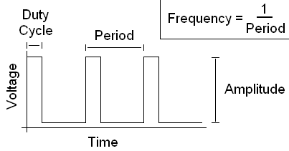
For example if you have 100 Hz PWM signal with 10% duty cycle the signal is high 1100s0,1=0.001s and low 0.009 s.

Following image shows how different duty cycles look like.
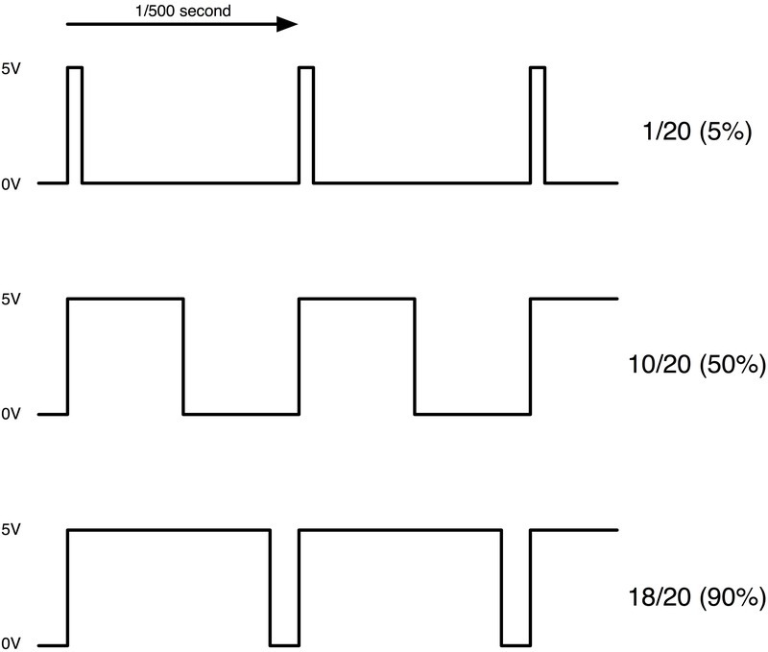
Using this signal to power some electrical devices allows us to control the amount of power used by the device. In case of LED-s, this changes brightness, while with motors we can adjust the rotational speed.

H-bridge
You will be using a module based on MC33887 H-bridge. The board have five pins you will have to connect to Raspberry Pi:
- PWM - connect to GPIO
- DIR1 - connect to GPIO
- DIR2 - connect to GPIO
- VCC - connect to 3V3
- GND - connect to ground
Here you can see which pin on the module corresponds to which signal.
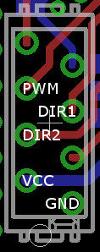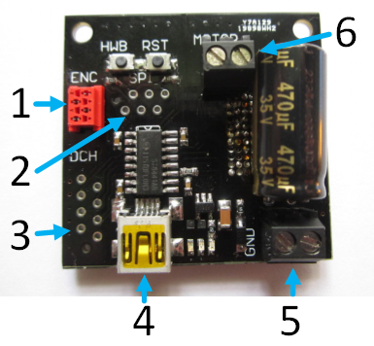
Module also has input for the higher voltage, used for the motor and output for the motor.
Description of connectors:
- 3 - control signals, connect to Pi
- 5 - motor power input, connect to GOPIGO motor output
- 6 - motor output, connect to GOPIGO motor
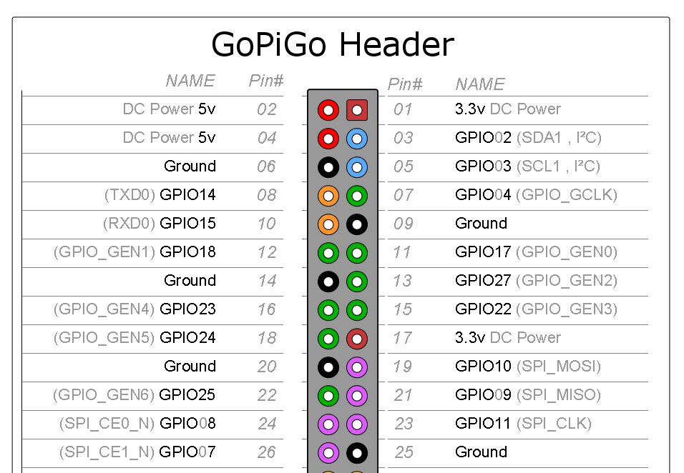

Shut down the Pi and disconnect the power before connecting the wires.

Connect input screw terminal to the GOPIGO motor output and output screw terminal to the robot’s motor.
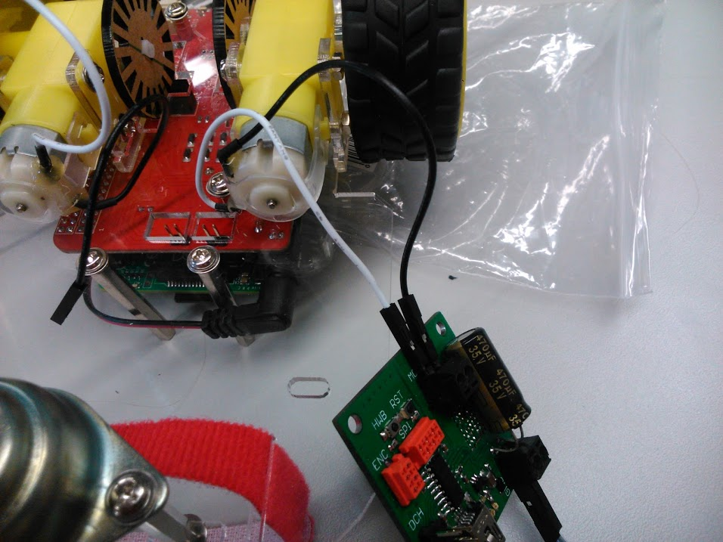
Connect the module to the Pi. You can use the pins on the GoPiGo module as these are directly connected to the Raspberry Pi. Header pinout can be seen above.
ATTENTION!!! Show your connections to the instructors before powering on the Raspberry Pi!! These motor controller boards have some sensitive components.
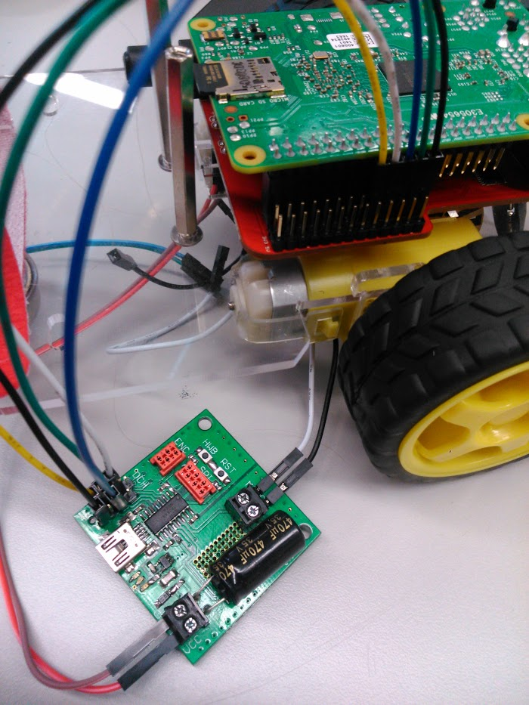

Controlling the motor
Since we connected the power input to the motor output of the GoPiGo, we will need to set the motor outputs active for it to work properly. Before you do this, set the PWM, DIR1 and DIR2 signals all to LOW to make sure you don’t unintentionally activate your motor. You can do this with the following code:

from gopigo import *
import RPi.GPIO as GPIO

# pin numbers are defined here, yours may be different
PWM = 10
DIR1 = 9
DIR2 = 11

# reference pins by GPIO numbers
GPIO.setmode(GPIO.BCM)
# disable warnings
GPIO.setwarnings(False)

# set pins as outputs
GPIO.setup(PWM, GPIO.OUT, initial=GPIO.LOW)
GPIO.setup(DIR1, GPIO.OUT, initial=GPIO.LOW)
GPIO.setup(DIR2, GPIO.OUT, initial=GPIO.LOW)

# give power to motor
set_speed(255)
motor_bwd()

# Enter your code here
GPIO.output(row_pins[3], GPIO.HIGH)
stop()

At the end of the code, stop() is used to cut the power from the motors.

You can change the direction of the motor by setting DIR1 and DIR2. For example if DIR1 is high, motor spins clockwise and when DIR2 is high, motor spins counterclockwise. If both of them are high or low, the motor is stopped.

Motor speed can be changed by applying PWM signal to the PWM pin. Speed depends on the duty cycle.

Task 1
Control speed and direction of one motor. Do not use built in functions to generate PWM. You can create PWM signal manually by setting pins high and low (GPIO.output(pin_number, GPIO.HIGH/LOW)) and using the time.sleep(wait_time) command. Note that the frequency of the signal (time_high + time_low) should remain constant. Show your code.

Task 2
Control both motors of the robot with the built in RPi.GPIO PWM functions. Write functions to make the robot go:
- forward(speed, time)
- backwards(speed, time)
- left(speed, time)
- right(speed, time)
Show the code and the moving robot.
Documentation for built-in GPIO PWM can be found here: https://sourceforge.net/p/raspberry-gpio-python/wiki/PWM/

Servo motors
First read a description about continuous rotation servo motors: https://learn.adafruit.com/adafruit-motor-selection-guide/continuous-rotation-servos

Servo motor has three pins:
- black - GND
- red - +5V
- white - PWM

Shut down the Pi and disconnect the power before connecting the wires.

Connect the red and black wire to Pi’s 5V and GND and connect the white wire to the desired GPIO pin. To control the rotation speed and direction, you need to apply 50 Hz PWM signal and vary the duty cycle.

Task 3
Control motor like this:
- Max speed clockwise for two seconds
- Half speed clockwise for two seconds
- Half speed counterclockwise for two seconds
- Max speed counterclockwise for two seconds
Use trial and error to find out which duty cycle corresponds to which speed and direction.
Show the completed task.
https://www.parallax.com/sites/default/files/downloads/900-00008-Continuous-Rotation-Servo-Documentation-v2.2.pdf

